BRAC University (Department of Computer Science and Engineering)

CSE 221 (Algorithms) for Spring 2025 Semester

Quiz 3
Student ID:
Section: Full Marks: 20

Name: Duration: 25 minutes

- You have just joined a new university and are exploring the campus, which consists of several buildings connected by one-way bridges. These bridges form a directed graph, where each node represents a building and each edge represents a bridge between two buildings. (6 + 6 + 2)
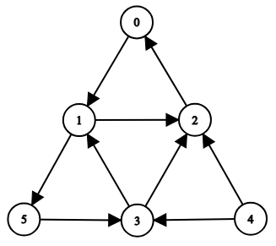
  - Apply the DFS algorithm on the following graph starting from vertex 0. Determine start
time, finish time for each of the vertices. Choose the smallest vertex when there is a choice.
  - From Figure 1 Simulate an algorithm to find the Strongly Connected Components (SCC). You don’t have to repeat any step you have done in a.
  - Suppose a bridge gets blocked. Explain in which case no. of SCCs will be the same.

- The 8 divisions in Bangladesh are connected through highways as given in the map below.
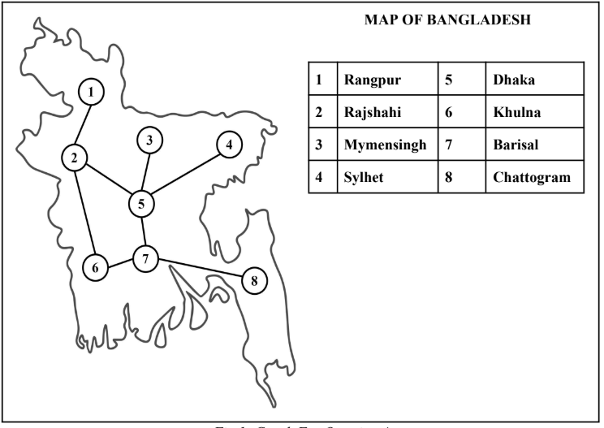
Suppose Dhaka suddenly gets affected with covid-19. The rest of the divisions are non-affected. You
are asked to find out the time steps the covid virus will take to affect all the non-affected cities if it
takes one time step to travel from one division to another. So, one affected division will affect all of its neighbors in one time step. (1 + 5)
a) Mention the name of the graph traversal algorithm you think is suitable for solving the
problem.
b) Simulate the suitable algorithm to find the time steps needed for each non affected division to
be affected. Choose the smallest vertex when there is a choice.

